Project Development Phase
Model Performance Test

Date | 12 February 2026
Team ID | LTVIP2026TMIDS77787
Project Name | Electric Motor Temperature Prediction using Machine Learning
Maximum Marks

Model Performance Testing:
Project team shall fill the following information in model performance testing template.
S.No. | Parameter | Screenshot / Values
 | Data Rendered | 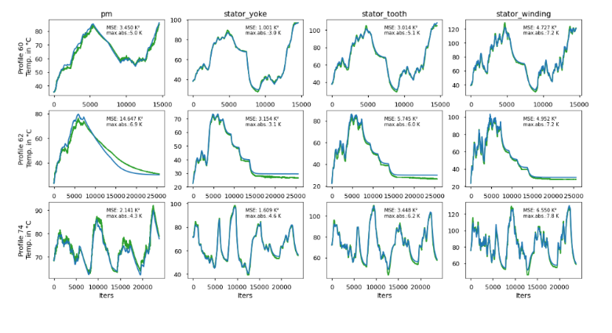  The dataset containing motor sensor temperature values such as pm, stator_yoke, stator_tooth, and stator_winding was successfully rendered and visualized. Each subplot represents the comparison between actual and predicted temperature values across iterations.
 | Data Preprocessing | 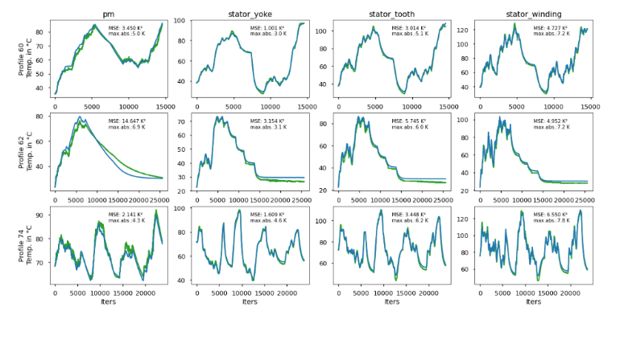  The dataset was preprocessed by handling missing values, normalizing numerical features, and preparing training and testing sets. This ensured consistent model performance and reduced prediction error.
3. | Utilization of Data Filters | Data filtering techniques were applied to isolate specific motor components such as pm, stator_yoke, stator_tooth, and stator_winding. This allowed individual performance analysis of each temperature profile.
4. | DAX Queries Used | Not Applicable – The project uses Python-based data processing and machine learning techniques instead of DAX queries.
5. | Dashboard design | No of Visualizations / Graphs – 12  The dashboard includes multiple line charts comparing actual vs predicted temperature values for different motor components. Performance metrics such as MSE and maximum absolute error are also displayed within each visualization.
6 | Report Design | No of Visualizations / Graphs -12  The report presents model evaluation through graphical comparisons and error metrics for each temperature profile. The visualization layout supports clear understanding of prediction accuracy and model stability.

